Selenium WebDriver

AUTOMATION TESTING TOOL

Jason Huggins -- 2004--THOUGHT WORKS

SELENIUM-2004- AUTOMATION TESTING TOOL

QTP- HP- MERCURY - Quick Test Professional

Selenium QTP

1. Open-source Commercial & Costly
2. Java,Python,Php,Ruby,Pearl VB Scripts- visual basic scripts
3. Firefox, Chrome,IE,Safari,Opera IE,FF- internet explorer - firefox
4. Windows,MAC,Linux,Solaris Windows
5. Web app,Mobile App Desktop,Web,Mobile
6. More Flexible Flexible

Selenium is basically used to automate the testing across various web browsers. It supports various browsers like Chrome, Mozilla Firefox, Safari, and IE(edge), and you can very easily automate browser testing across these browsers using Selenium WebDriver

n WebDriver, test scripts can be developed using any of the supported programming languages and can be run directly in most modern web browsers. Languages supported by WebDriver include C#, Java, Perl, PHP, Python and Ruby.

Selenium WebDriver is the most important component of Selenium Tool's Suite. The latest release "Selenium 2.0" is integrated with WebDriver API which provides a simpler and more concise programming interface.

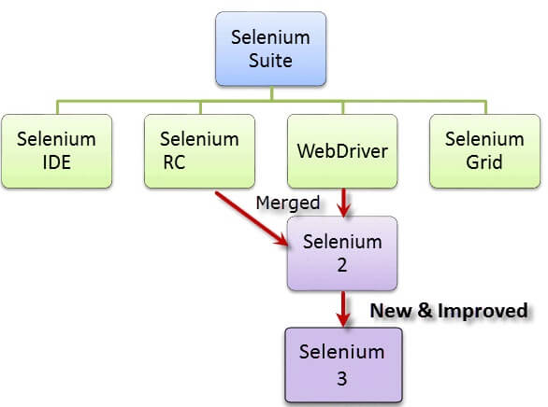

**Selenium Components:**

Selenium IDE

Selenium RC

Selenium WebDriver

Selenium Grid

**Selenium IDE:**

IDE - > Integrated Development Environment

It can be used only in FireFox.

We cannot be used for compliment test Cases.

**Selenium RC:**

RC - > Remote Control

In RC the installations are complicated.

It cannot directly interact with Browser.

**Selenium WebDriver:**

It is a automation testing tool.

It Supports Different Browsers Along with Different Kind Of Programming languages.

Selenium WebDriver performs much faster as compared to Selenium RC because it makes direct calls to the web browsers. RC on the other hand needs a RC server to interact with the browser.

It Directly Interact with Browser

**Selenium Grid:**

It Is a HubNode Concept.

It Execute Test Cases Parallely And It Reduces the Execute Time.

-------------------------------------------------------------------------------------------------------------------------------

Web Application:

Browser - E-commerce ., Web application which is working with browsers

## **Selenium WebDriver- Architecture**

Selenium WebDriver API provides communication facility between languages and browsers.

The following image shows the architectural representation of Selenium WebDriver.

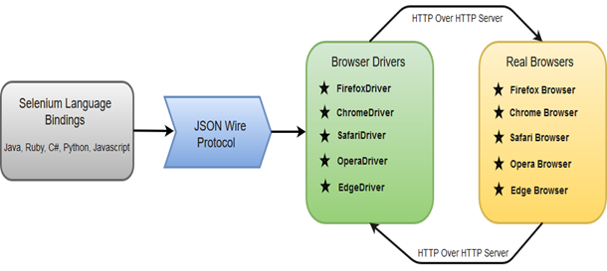

There are four basic components of WebDriver Architecture:

* Selenium Language Bindings 🡪Selenium developers have built language bindings/Selenium Client Libraries in order to support multiple languages.
* JSON Wire Protocol 🡪JSON Wire Protocol provides a transport mechanism to transfer data between a server and a client.
* Browser Drivers 🡪Selenium uses drivers, specific to each browser in order to establish a secure connection with the browser
* Real Browsers

Browsers supported by Selenium WebDriver:

* Internet Explorer
* Mozilla Firefox
* Google Chrome
* Safari

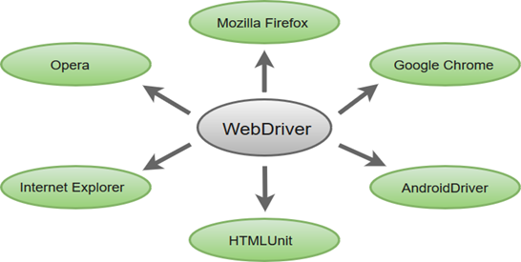

* **Multiple Languages Support**: WebDriver also supports most of the commonly used programming languages like Java, C#, JavaScript, PHP, Ruby, Pearl and Python.
* **Speed**: WebDriver performs faster as compared to other tools of Selenium Suite

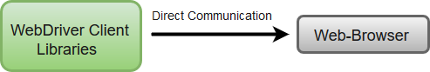

* **Simple Commands**: Most of the commands used in Selenium WebDriver are easy to implement. For instance, to launch a browser in WebDriver following commands are used:

